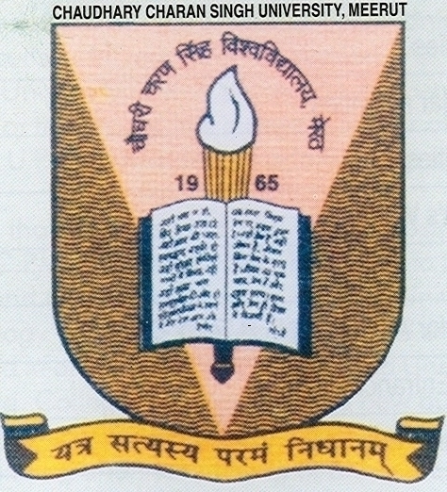

**DIRECT ADMISSION TO FIRST YEAR OF B.TECH (EC, EI, CS, IT, AG, ME, CH), MCA, MBA, MBA-IB & SECOND YEAR (Lateral Entry) TO B.TECH (EC, EI, CS, IT, AG, ME, CH) & MCA, AGAINST VACANT SEATS AFTER UPTU COUNSELLING 2016 FOR SESSION 2016-17.**

**B.TECH.:-** The candidates who have passed intermediate (PCM) and obtained 55% (Gen/OBC) and 50% SC/ST will be given admission in B.Tech as per merit. Candidates having 55% marks FOR Gen/OBC and 50% for SC/ST in Diploma/B.Sc. may also apply for admission through Lateral Entry in IInd Year of B.Tech..

**MCA**. Who have cleared their UG (with Math in 10+2) and obtained 55% marks Gen/OBC and 50% marks SC/ST will be given admission in Ist year and who have cleared B.Sc.(CS/IT) & BCA and obtained 55% marks Gen/OBC and 50% marks SC/ST will be given admission in 2nd year of MCA.

**MBA & MBA (IB):-** Candidates who have cleared their graduation and obtained 55% Gen/OBC and 50% SC/ST will be given admission in MBA & MBA (IB).

Desirous candidates have to register themselves at the institute along with a DD of **Rs. 1000/-** (for Gen/OBC) and **Rs. 600/-** (for SC/ST) in favour of **"F. O., CCS University, Meerut" payable at Meerut**  **latest by 09 Aug. 2016.**

**For vacant seats**. The admission will be strictly as per prepared merit which will be declared on 10 Aug. 2016 at 5:00 PM on the institute website WWW.CCSUSCRIET.ORG. Students having agriculture & biology educational background will be given admission in Agri. Branch only. Branch will be allotted as per merit. Counseling will be done on 11th & 12th Aug. 2016 for all above Courses at SCRIET.

**REGISTRAR**

MORE DETAILS REGARDING DIRECT ADMISSION TO FIRST YEAR OF B.TECH.( EC,EI,CS,IT,AG,ME,CH) , MCA, MBA, MBA-IB & SECOND YEAR (Lateral Entry ) TO B.TECH.( EC,EI,CS,IT,AG,ME,CH) , MCA, AGAINST VACANT SEATS UPTU AFTER COUNSELLING 2016 FOR SESSION 2016-17

1. The admission will be done in all courses as per merit strictly.
2. Branches in B. Tech 1st year and 2nd year (Lateral Entry) will be allotted as per merit list strictly.
3. The merit will be declared on 10th August 2016 at 5.00 PM on our institute web site [www.ccsuscriet.org](http://www.ccsuscriet.org)
4. Counseling will be done on 11th & 12th August 2016 for all courses at SCRIET.
5. Desirous candidates have to register themselves at the institute along with a DD of 1000/-(for Gen/OBC) and Rs 600/-( for SC/ST) in favor of Finance Officer, CCS University, Meerut. Latest by 10 August 2016.
6. All candidates are instructed to carry 2 passport size photograph and one set of photocopy of all documents along with all original documents for verification at the time of registration and counseling.
7. Candidate who are interested to take admission in B. Tech. 1st year must have qualified intermediate (PCM). ( 55% Marks for Gen/OBC and 50% Marks for SC/ST Candidates)
8. Candidates who are interested to take admission in B. Tech 2nd year ( Lateral Entry) must have qualified Polytechnic Diploma / B.Sc (PCM Group) (55% Marks for Gen/OBC and 50% Marks for SC/ST Candidates).
9. Candidates who are qualified from Agriculture / Biology Back ground will be given admission in B.Tech (AG) branch only.
10. Candidates who are interested to take admission in MCA 1st year must have cleared their UG with Mathematics at 10+2 level) (55% Marks for Gen/OBC and 50% Marks for SC/ST Candidates) and in MCA 2nd Year (Lateral Entry) must have cleared their UG (BCA/ B.Sc. (CS / IT) (55% Marks for Gen/OBC and 50% Marks for SC/ST Candidates).
11. To avail advantage of cast / category candidates must attach the cast certificate at the time of admission/ counseling

**SIR CHHOTU RAM INSTITUTE OF ENGINEERING & TECHNOLOGY**

**Ch. Charan Singh University Campus, Meerut-250 005**

**(AICTE Approved)**



**B.Tech Course Fee Structure (Session 2016-17)**

**The Annual Fee Structure for the 1st year & 2nd year (lateral Entry) is as follows: -**

## 1. Tuition Fee - Rs. 72500/-

2. Development Fee - Rs. 5000/-

3. Sports Fee - Rs. 400/-

4. Training and Placement Fee - Rs. 400/-

5. Student Welfare Fund - Rs. 400/-

6. Student Aid Fund - Rs. 400/-

7. Project/Research/Seminar - Rs. 400/-

8. Medical - Rs. 400/-

9. General Insurance - Rs. 100/-

**Total Rs. 80,000/-**

Security (Refundable) **Rs. 5000/-**

**Grand Total 85,000/-**

**In words: (Rupees Eighty Five Thousand Only)**

**MCA Course Fee Structure (Session 2016-17)**

**The Annual Fee Structure for the 1st year & 2nd year (lateral Entry) is as follows: -**

## 1. Tuition Fee - Rs. 42500/-

2. Development Fee - Rs. 5000/-

3. Sport Fee - Rs. 400/-

4. Training and Placement Fee - Rs. 400/-

5. Student Welfare Fund - Rs. 400/-

6. Student Aid Fund - Rs. 400/-

7. Project/Research/Seminar - Rs. 400/-

8. Medical - Rs. 400/-

9. General Insurance - Rs. 100/-  **Total Rs. 50,000/-**

**Refundable Security Rs. 5,000/-**

**Grand Total 55000/-**

**MBA, MBA(IB) Course Fee Structure (Session 2016-17)**

**The Annual Fee Structure is as follows: -**

## 1. Tuition Fee - Rs. 42500/-

2. Development Fee - Rs. 2500/-

3. Computer Fee - Rs. 2500/-

3. Sports Fee - Rs. 400/-

4. Training and Placement Fee - Rs. 400/-

5. Student Welfare Fund - Rs. 400/-

6. Student Aid Fund - Rs. 400/-

7. Project/Research/Seminar - Rs. 400/-

8. Medical - Rs. 400/-

9. General Insurance - Rs. 100/-  **Total Rs. 50,000/-**

**Refundable Security (for first year only) Rs. 5,000/-**

**Grand Total 55000/-**